**DAILY ONLINE ACTIVITIES SUMMARY**

|  |  |  |  |  |  |  |  |  |
| --- | --- | --- | --- | --- | --- | --- | --- | --- |
| **Date:** | **13-06-2020** | | | | | **Name:** | **Preethi** | |
| **Sem & Sec** | **6th - B** | | | | | **USN:** | **4AL17CS065** | |
| **Online Test Summary** | | | | | | | | |
| **Subject** | | **PAP** | | | | | | |
| **Max. Marks** | | **30** | | **Score** | | | **30** | |
| **Certification Course Summary** | | | | | | | | |
| **Course** | **Python for Data Science** | | | | | | | |
| **Certificate Provider** | | | **Cognitive Class-IBM**  **DeveloperSkillsNetwork** | | **Duration** | | | **7hours** |
| **Coding Challenges** | | | | | | | | |
| **Problem Statement:2 Java,1 C and 1 python program** | | | | | | | | |
| **Status: executed** | | | | | | | | |
| **Uploaded the report in GitHub** | | | | | **Yes** | | | |
| **If yes Repository name** | | | | | <https://github.com/PreethiNayak/Daily-Status/tree/master/13June2020> | | | |
| **Uploaded the report in slack** | | | | | **Yes** | | | |

Online Test Details: (Attach the snapshot and briefly write the report for the same)

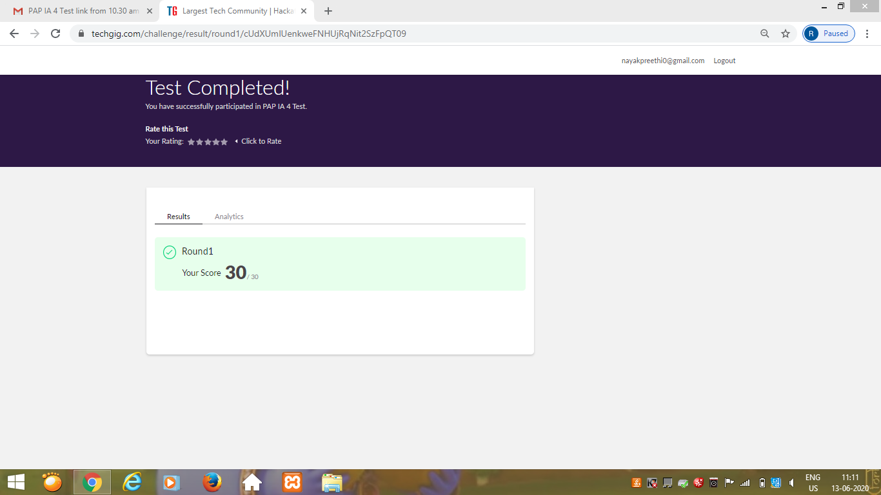

Certification Course Details: (Attach the snapshot and briefly write the report for the same)

Today I attempted final test on “Python for Data Science” course and completed this course.

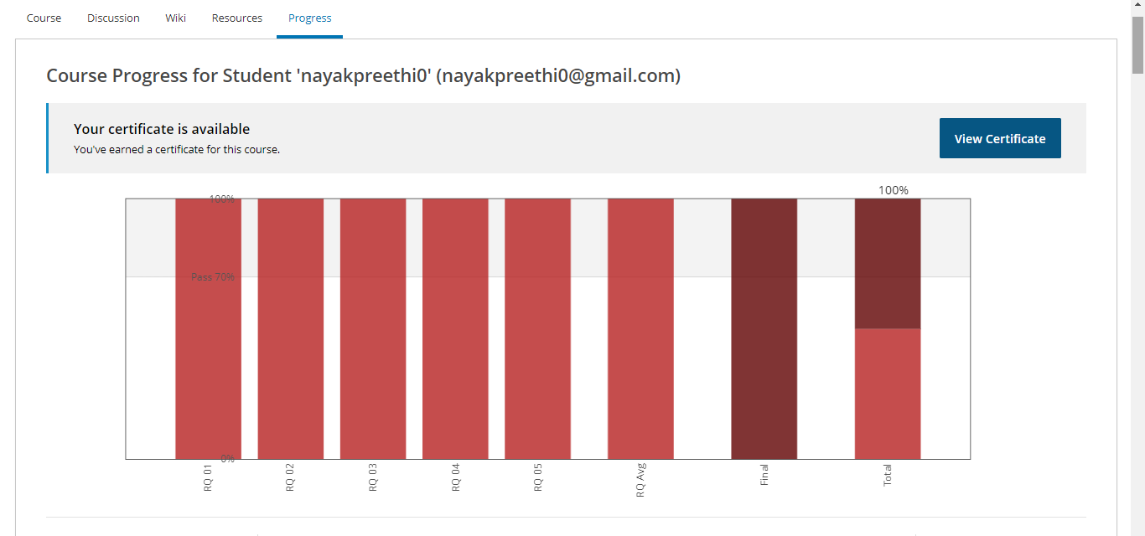

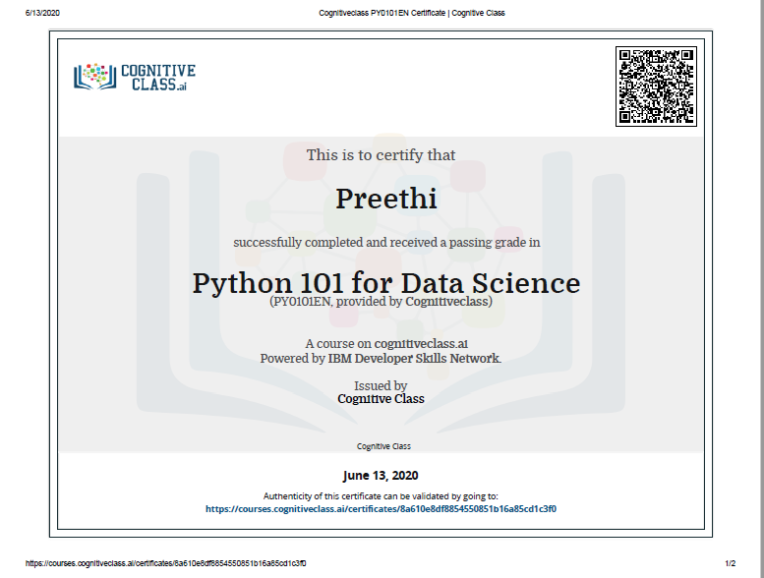

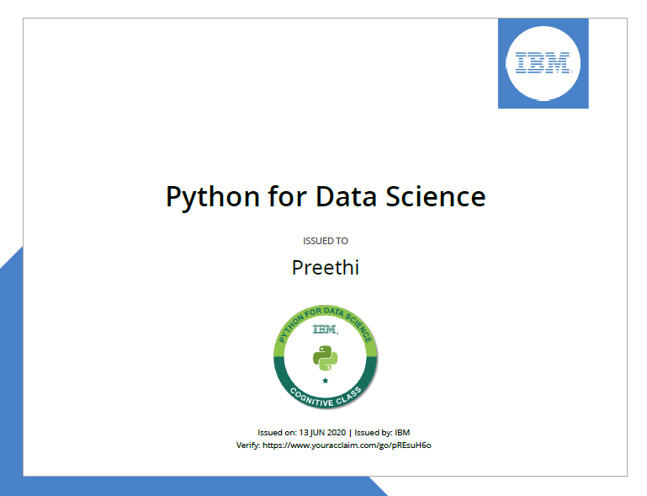

Coding Challenges Details: (Attach the snapshot and briefly write the report for the same)

Program 1

This is output of C program to calculate Electricity Bill.

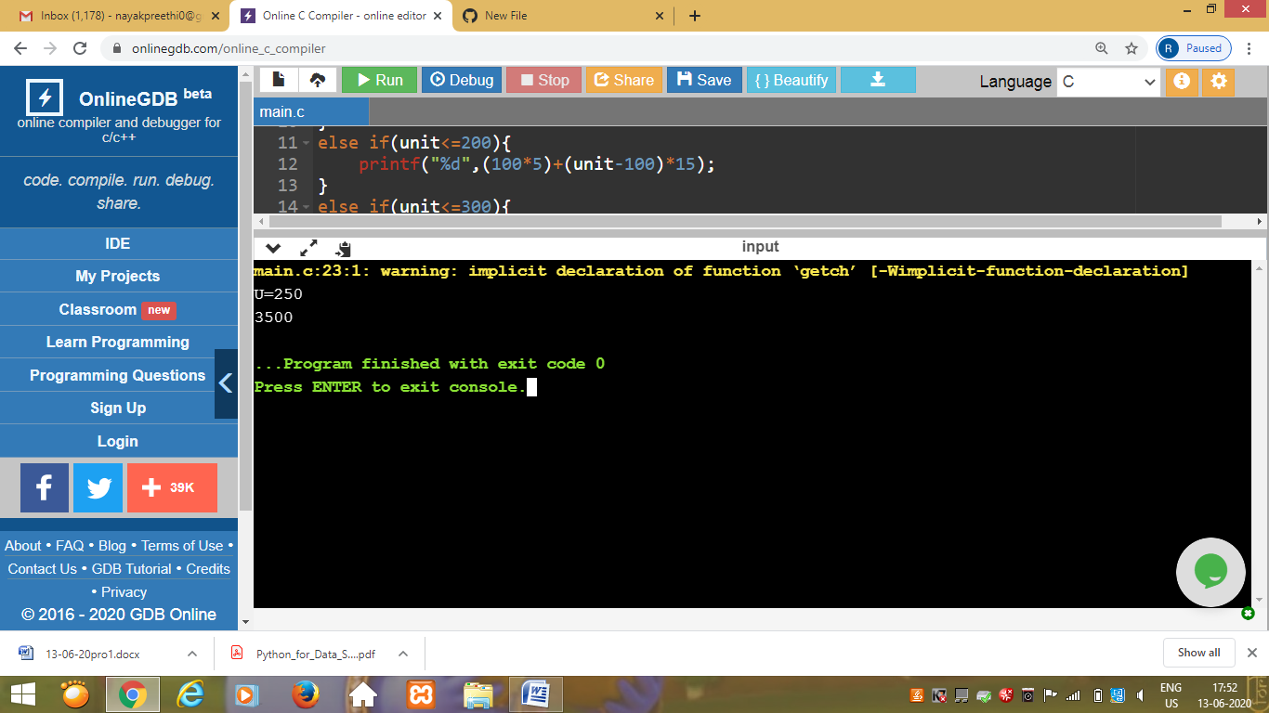

Program 2

This is the output of the java program to find the first non repeated character of a given String.

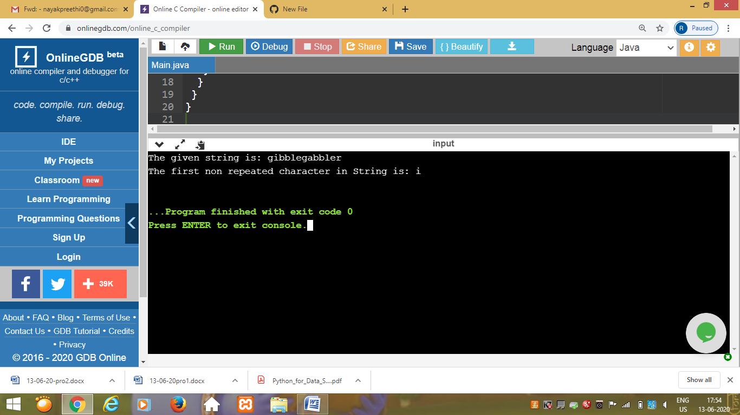

Program 3

## This is the output of java program to  determine whether a given matrix is a sparse matrix.

## Screenshot (284).png

## Program 4

## This is the output of Python program to print the pattern as shown in snapshot.

